SCULPTURETOUR SALINA COMPETITION & EXHIBITION | DEADLINE 12.23.2022

Call For Entries

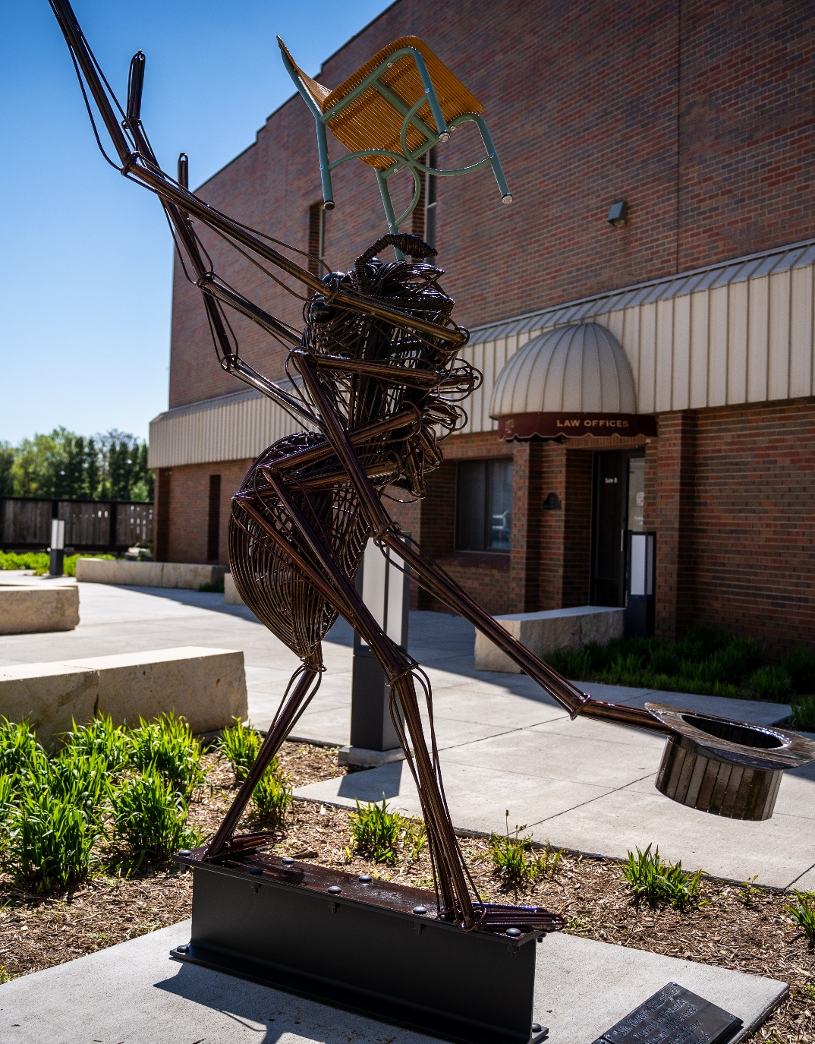

SculptureTour Salina (STS) is an annual juried competition and exhibition in Salina, Kansas. Salina is an extraordinary community boasting cultural organizations and venues of national acclaim.

The exhibition is open to all artists creating works suitable for outdoor display. Between 18 and 25 sculptures are selected and carefully sited in historic downtown Salina. Sculptures
remain installed for one year and the program is marketed to provide both viewing enjoyment to community and visitors as
well as a sales opportunity for participating artists.

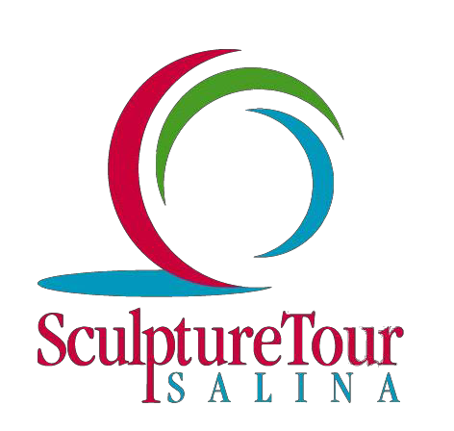

2022 BEST OF SHOW
“Mr. Hatter’s Anthropodal Pursuits in Becoming Human: 002 Balance” Brady Hatter, KS
To date, more than 40 sculptures have been purchased by local businesses and individual.
An additional 11 People’s Choice Award winners have been purchased and placed within the community. The City of Salina designates up to $15,000 for the purchase of the People’s Choice winner (see page 2 for details). The sculpture is then installed in a public environment within the community as part of Salina’s growing public art collection.

In addition to the People’s Choice Award, $4,750 in Juror’s Merit Awards and $1,500 in Public Merit Awards will also be given.

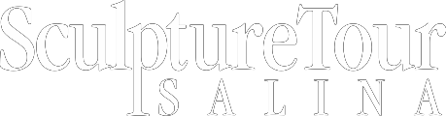
SCULPTURETOUR SALINA COMPETITION & EXHIBITION | DEADLINE 12.23.2022
Call For Entries

Exhibition Selection
The Selection Jury consists of seven members: STS Chair, Selection Jury Chair, an appointee from Salina Arts & Humanities and Salina Art Center, a STS sponsor and two additional qualified art professionals. Sculptures will be selected based on quality, artistic merit, design, craftsmanship, creative use of materials, scale, weather appropriate, and durable and safe for community display. Works will be selected in a wide range of media and expression.

Downtown Excitement
One of the biggest transformative projects in the history of Salina downtown was completed in 2020. Within the historic space we have a new entertainment center, several new restaurants, a five-story hotel, an athletic fieldhouse and other amenities, attractions, and retail shops. Our new classic automotive museum, The Garage, and
large-scale mural projects adorn the downtown! Within this renovation, new sculpture pedestals were added to our new and enlarged pedestrian-friendly sidewalks.

STS Policies
▪Application fee is $25, per artist,
Due by December 23, 2022.
▪Selected sculptures will be on display for one-year, early May through early April.
▪Sculptures are required to remain installed for the duration of the exhibition.
▪A stipend of $1,000 maximum ($750 for delivery and up to $250 toward return freight) is awarded for each accepted sculpture.
▪Artists have the option to list their artwork for sale.
▪Artists have the option to participate in the People’s Choice Award program. (See application form.)
▪SculptureTour Salina (STS) retains
25% commission on all sold artworks.
▪STS provides technical assistance during installation of artwork.
▪Work has also been commissioned from participating artists as well

Artist Requirements
▪ All artwork must be the original work of the submitting artist.
▪ Artists are responsible for round-trip
shipment of artwork and may opt to provide installation instruction or personally assist with installation of the work(s).
▪ Artists may submit up to three (3)
sculptures for consideration.
▪ Artworks submitted must have at least one dimension that is no less than three (3) feet, excluding base.
▪ ONLY high resolution (1920 x 1920 pixels minimum) digital baseline JPEG images will be accepted. No progressive JPEG files will be accepted.
▪ Artwork images may be submitted by disc or email with artist’s name, title of artwork, dimensions (excluding base), year completed, medium and process description. (See entry form)
▪ Artists MUST submit three (3) separate views of each artwork (front, side and back). Artworks submitted without three views may not be considered.
▪ Artists are to designate whether the artwork is for sale and provide a purchase price.
▪ Artists must designate whether the piece is to be considered for the People’s Choice Award program (purchase price up to
$15,000)
▪ Artist’s resume/short bio/statement must be included in the application.
Submission Requirements
▪ Must include a $25 non-refundable application fee, per artist for 1-3 submissions)
▪ Completed entry form (by mail or email)
▪ Artist’s resume/short bio
▪ Three high resolution JPEG images per artwork clearly showing front, side and back views
▪ Artist’s resume/short bio
▪ A brief artist statement of each piece to be shared with jurors
▪ Applications MUST be postmarked or submitted online by December 23, 2021. Late entries will not be accepted.

Send completed application via email or mail to: SculptureTour Salina, PO Box 586 Salina, KS 67402-0586 OR email to:
srice@salinakansas.org
Questions: Sylvia Rice at 785-827-9310, x138 OR srice@salinakansas.org
Awards
A Juror will be selected to award $4,750 in cash awards during the opening day of SculptureTour – May 6, 2023. Juror’s Awards will be announced and presented following the Unwrap Party.
Jurors Merit Awards announced:
Best of Show: $2,500
Merit Award: $1,500
Merit Award: $750

People's Choice Awards:
The People's Choice Award is decided
by the public. The sculpture with the most votes by ballot through
December 31st will be purchased by the
City of Salina at listed sale price, up to
$15,000.
People's Merit Award: $1,000 award to artist is based on 2nd highest total number of votes. Children's Merit Award: $500 award to artist is based
on highest number of votes by children,
18 and under.

Calendar
Applications Due with$25 application fee, per artist by December 23, 2022
January 23, 2023: Jury notification
April 2023: De-installation of 2022 exhibit, Installation of 2023 exhibit begins
May 6, 2023: Opening day, UnWrap Party, Juror’s Merit Awards Announced
May 6-December 31, 2023: People’s Choice
Award Voting Period
January 2024: 2023 People’s Choice Award
Announcement
April 2024: De-installation of 2023 exhibit

SCULPTURETOUR SALINA COMPETITION & EXHIBITION FINAL DEADLINE 12.23.2022
Application Form
Application Checklist
Be sure you have included/attached:
- COMPLETED entry form(right)
- Three high res photos depicting front, back and side views of each entry
- Artist resume/short bio
- $25 non-refundable application fee
- Brief artist statement of each piece

Entry One

TITLE:

MEDIUM:

NOTE: You may complete this form to be e-mailed or mailed OR go to www.sculpturetoursalina.net and click on “Artists” to complete the application online.

APPLY TODAY!
We invite you to submit your application to the twelfth
SculptureTour Salina exhibition, May 2023-April 2024. The Salina community has enthusiastically embraced this program and welcomes your participation!

SculptureTour Salina actively promotes the sale of artworks each year, encouraging corporate and private purchases in the community. To date, more than 40 sculptures have sold, with the City of Salina’s purchase of the People’s Choice Award sculptures each year. Work has also been commissioned with participating artists.
TECHNIQUE/PROCESS:

DIMENSIONS, EXCLUDING BASE:

HEIGHT: WIDTH: DEPTH WEIGHT: YEAR COMPLETED: FOR SALE? Y/N SALE PRICE: $ *PEOPLE’S CHOICE PARTICIPANT? Y/N

Entry Two

TITLE:

ARTIST NAME
MEDIUM:

ADDRESS

TECHNIQUE/PROCESS:

CITY/STATE/ZIP

PHONE

CELL PHONE

DIMENSIONS, EXCLUDING BASE:

HEIGHT: WIDTH: DEPTH WEIGHT: YEAR COMPLETED:

EMAIL WEBSITE

How to Submit Your Application
Submit up to three (3) entries, with these required items:
1. Complete application/Entry forms
2. Three (3) high-res JPEG images (1 each front, back, side views – PER ENTRY
3. Artist resume/short bio
4. Payment of non-refundable application fee
$25 per artist

MAIL TO: SculptureTour Salina, PO Box 586, Salina, KS 67402-0586; OR
EMAIL TO: srice@salinakansas.org ; OR Online: www.sculpturetoursalina.com
FOR SALE? Y/N SALE PRICE: $ *PEOPLE’S CHOICE PARTICIPANT? Y/N

Entry Three

TITLE: MEDIUM: TECHNIQUE/PROCESS:

DIMENSIONS, EXCLUDING BASE:

HEIGHT: WIDTH: DEPTH WEIGHT: YEAR COMPLETED:

FOR SALE? Y/N SALE PRICE: $ *PEOPLE’S CHOICE PARTICIPANT? Y/N
*People’s Choice Award winner is determined by public ballot. Winning sculpture is purchased by City of Salina at listed purchase price, up to $15,000.

